Hostel Room Booking and Fees Management System

Group 14 Project Report

Name | Registration Number
KABAROKOLE ALLEN | VU-BBC-2603-2337-DAY
RODNEY KAZIBWE | VU-BBC-2603-2345-DAY
NAMBWAYO JOAN | VU-BCD-2603-3499-DAY
MUKASA ABDALLAH MULINDWA | VU-BIT-2603-1917-DAY
LUAL MAYEN DENG | VU-BIT-2603-2477-DAY
AROU ELIJAH KUR | VU-BCS-2407-2721-DAY
MUHIRWA TRINITY | VU-BCD-2603-3341-DAY
LUGOBE EDRINE MUSISI | VU-DIT-2603-2860-DAY
NAMPIJJA SHARIFAH | VU-DIT-2603-2976-DAY
AKUNDA SANDRA | VU-BSF-2603-2865-DAY

- Introduction
University hostel wardens have traditionally tracked room bookings and fee payments using a paper ledger, a process that is slow and prone to human error. This project replaces that ledger with a Python-based Hostel Room Booking and Fees Management System. The system predefines the hostel's blocks and rooms, allocates incoming students to rooms with available capacity, records their fee payments over time, and gives the warden simple search and reporting tools. All data persists between runs in a local JSON file, so the warden never has to re-enter existing records.
- System Design
The system is split into six single-responsibility modules so that the group can divide the work cleanly and each function remains easy to read, test, and maintain. A menu-driven driver programme (main.py) ties the modules together into one looping interface intended for a warden with no programming background. Every input is validated, and invalid choices or non-numeric entries are re-prompted rather than crashing the programme.

Module | Purpose | Key functions
hostel_data.py | Defines the 3 hostel blocks, their rooms and bed capacities; prints the startup occupancy overview. | create_hostel_blocks() print_occupancy_overview()
registration.py | Registers a student and allocates them to a room, checking remaining capacity before accepting. | register_and_allocate_student()
payment.py | Records full or partial payments and computes each student's running outstanding balance. | record_payment() get_outstanding_balance()
reports.py | Searches students by name/reg. no.; builds the occupancy report and the fee-defaulters list. | search_student() generate_occupancy_report() generate_fee_defaulters()
Hostel_data.py | Loads all data to hostel_data.json; falls back to fresh defaults if the file is missing or damaged. | save_data() load_data()
main.py | Ties every module together behind one looping, input-validated menu for the hostel warden. | main() print_menu() get_non_empty_input() get_non_negative_number_input()

- Data structures
Hostel data is held as a dictionary of blocks, each mapping room numbers to a record containing the room's bed capacity and a list of the registration numbers currently occupying it (hostel_blocks[block][room] = {capacity, occupants}). Student data is a second dictionary keyed by registration number, storing the student's name, allocated block/room, total fee, amount paid so far, and a full payment history list with a timestamp per payment. Both dictionaries map directly onto JSON, which keeps file persistence (module e) simple and avoids a separate conversion step.
Choosing plain dictionaries over custom classes kept the code approachable for every member of the group regardless of prior Python experience, while still cleanly separating the two real-world entities in the system: hostel rooms and students.
- Division of Work
The task was divided along the same six modules described above, so that each member owned a self-contained file with a clear interface (inputs and return values) that the others could call without needing to know its internal implementation. This made integration straightforward: once each member's functions matched the agreed signatures, main.py simply imported and called them.
Name | Registration Number | Module(s) Responsible For | Primary Code File
KABAROKOLE ALLEN | VU-BBC-2603-2337-DAY | Student registration & room allocation | Registration.py
RODNEY KAZIBWE | VU-BBC-2603-2345-DAY | Student registration & room allocation | Registration.py
NAMBWAYO JOAN | VU-BCD-2603-3499-DAY |  | Hostel data.py
MUKASA ABDALLAH MULINDWA | VU-BIT-2603-1917-DAY | Search & reporting; File persistence | reports.py
LUAL MAYEN DENG | VU-BIT-2603-2477-DAY | Data setup; Menu-driven driver programme | main.py
AROU ELIJAH KUR | VU-BCS-2407-2721-DAY | Search & reporting; File persistence | reports.py
MUHIRWA TRINITY | VU-BCD-2603-3341-DAY | Data setup; Menu-driven driver programme | main.py
LUGOBE EDRINE MUSISI | VU-DIT-2603-2860-DAY |  | Hostel data.py
NAMPIJJA SHARIFAH | VU-DIT-2603-2976-DAY | Fee payment recording | payment.py
AKUNDA SANDRA | VU-BSF-2603-2865-DAY | Fee payment recording | payment.py

- Challenges Overcame
- Tracking partial payments correctly: recording several payments for the same student without losing the running total required storing a payment_history list rather than overwriting a single "amount paid" value each time. This also gives the warden a clear audit trail per student.
- Rejecting a full room with a clear reason: allocation checks the room's current occupant count against its capacity before adding a student, and returns a specific message (e.g. "already full (2/2)") rather than a generic error, so the menu layer can show the warden exactly why the request failed.
- Handling a missing or damaged data file gracefully: the first run of the programme has no JSON file yet, and a manually edited or corrupted file could break JSON.load(). storage.py catches both FileNotFoundError-type conditions and JSONDecodeError, and falls back to a fresh default data set with a warning instead of crashing.
- Keeping a consistent coding style across four contributors: the group agreed on snake_case naming, one docstring per function, and a shared "return (success, message)" pattern for any function that can fail, so every module reports outcomes the same way and main.py could handle them uniformly.
- Validating input from a non-technical user: the menu layer re-prompts on empty text fields and non-numeric fee/payment amounts instead of letting a bad entry propagate into the data layer and cause inconsistent records.
- This is the source code from the GitHub link:
- Screenshots during the system in operation
The following screenshots were captured from a real run of main.py, demonstrating the menu flow end to end: startup with the occupancy overview, student registration, fee payment, search, the full occupancy report, and the fee-defaulters report.
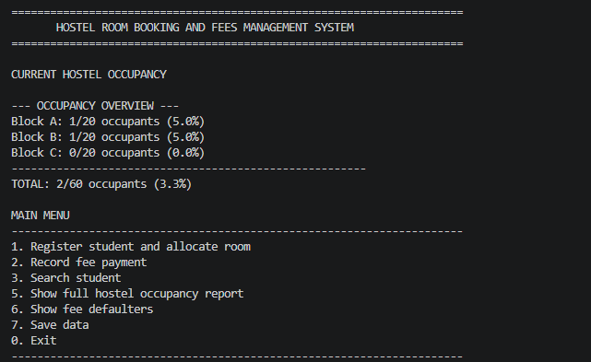
Startup occupancy overview, student registration.
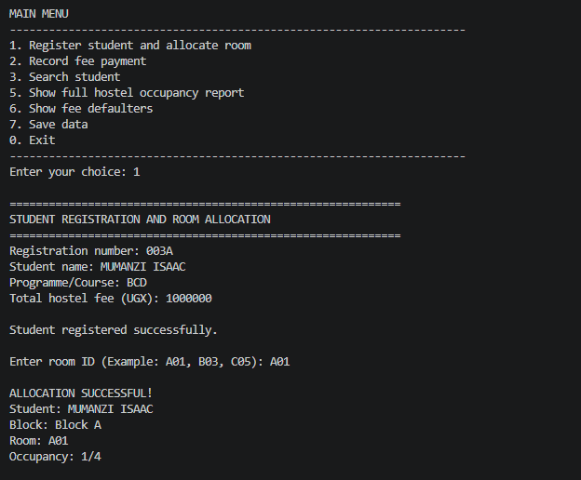
Recording fee payments against student accounts.
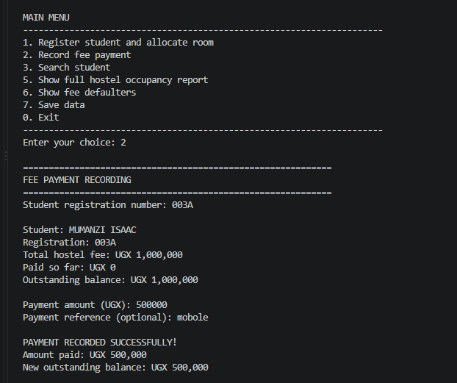This is a record fee payment.
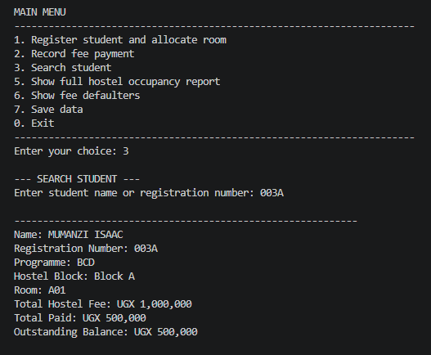
Searching for a student by name.
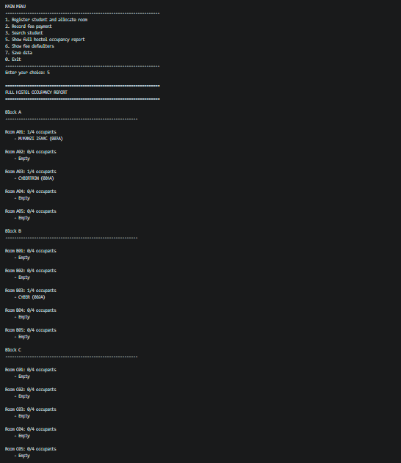
Fee defaulters report for a chosen balance threshold.
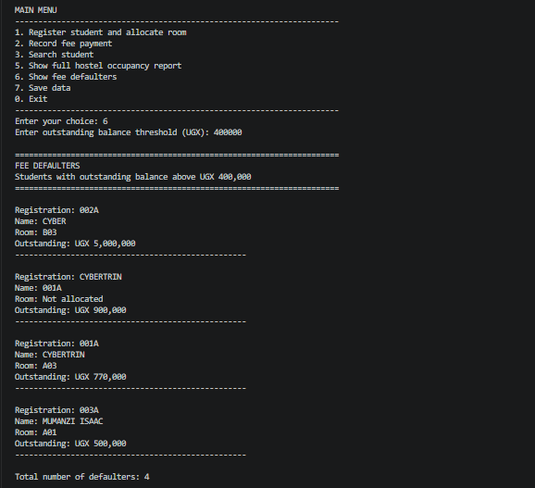
Fee defaulters report for a chosen balance threshold

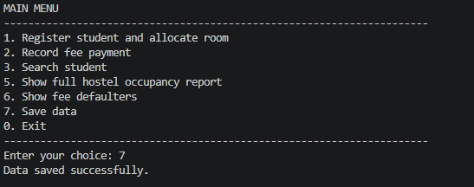
Data being saved in the system
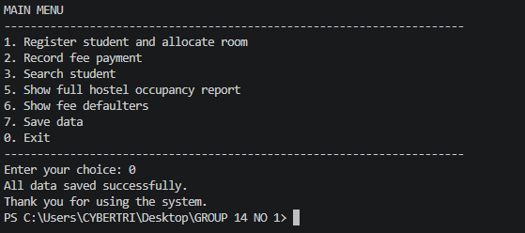
Confirmation of the saved data

